VISION MEASURING SYSTEMS

VIDEO

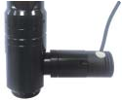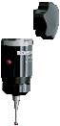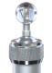
stylus
calibration ball

lens wit* coa6ial lig*t (optional, must be installed in 7actory)
probe (optional), includes Ø2mm and Ø3mm styli, Ø25mm calibration ball, measuring accuracy is 10µm

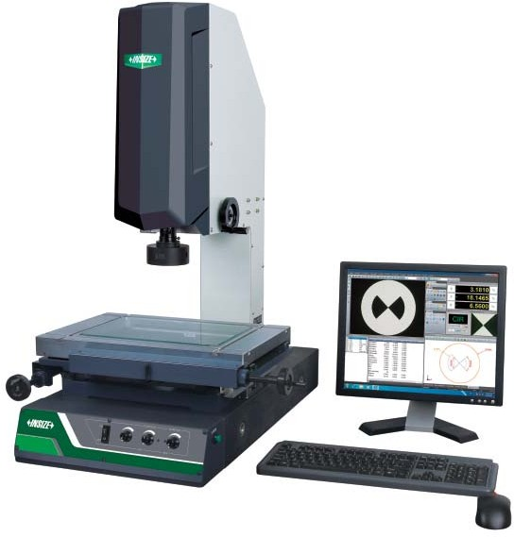S3ECI6ICATION
IS27V<;9A
computer is included
Code | IS27V:;9A | IS27V<;9A | IS27V899A | IS27V=99A
Measuring range (X!Y!Z# | 150!100!200mm | 250!150!200mm | 300!200!200mm | #00!300!200mm
Stage size | 35#!22%mm | #50!2%0mm | 500!330mm | 606!#66mm
Stage glass size | 210!160mm | 306!196mm | 350!250mm | #50!350mm
Resolution o$ X/Y%Z a&is | 0&5µm
Accurac( o$ X/Y a&is | '(3&5()/100)µm () is t*e measuring lengt* in mm)
Repeata)ilit( o$ X/Y a&is | 2µm
O)*ecti+e | 0&701#&50 (/oom)
Working distance | 92mm
Magni$ication | 33011950 (on 1922 monitor)
Camera | 1/322 color 334, 0&35 pi6el
Illumination | sur7ace and contour wit* ad8ustable )94
Ma&/ 0eig0t o$ 1orkpiece | 160mm
Ma&/ 1eig0t o$ 1orkpiece | 20$g
Operation s(stem | +indows 7/%/10
2ri+e met0od | manual
3o1er suppl( | 110/220V, 50/60H/
2imension (4!W!5# | 560!5#0!%50mm | 760!600!900mm | 760!600!900mm | 970!670!9#0mm
Weig0t | 100$g | 120$g | 1#0$g | 2#0$g

O3TIONA4 ACCESSORY
9/;X au&iliar( o)*ecti+e | 3ode: IS27V7O>9;X  +or$ing distance: 175mm  5agni7ication: 16&5197&50 (on 1922 monitor)
<X au&iliar( o)*ecti+e | 3ode: IS27V7O><X  +or$ing distance: 36mm  5agni7ication: 6613900 (on 1922 monitor)
3ro)e | 3ode: IS27V73RO>E  lncludes Ø2mm and Ø3mm styli, Ø25mm calibration ball
Vision measuring | 3ode: IS27V:;9AC4?
s(stem 1it0 | IS27V<;9AC4?
co&ial lig0t lens | IS27V899AC4?
(1it0 computer# | IS27V=99AC4
O$$ice so$t1are | 3ode: @8:87O66ICE

STAN2AR2 2E4IVERY
Main unit | 1 pc
Computer | 1 pc
Cali)ration glass c0art | 1 pc
Cla( | 1 pc
6oot s1itc0 | 1 pc
Anti7dust co+er | 1 pc

SO6TWARE (INC4U2E2#
Ce7er to page 2%0 7or details
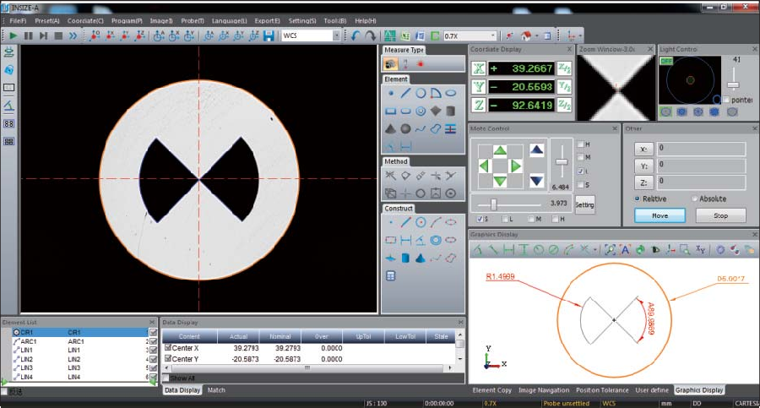real<time image

0/Y/@ a6is

lig*t controller

magni7ication o7
selected points

measuring grap*ic

measuring ob8ects measuring results
measuring tools
mo>ement controller

